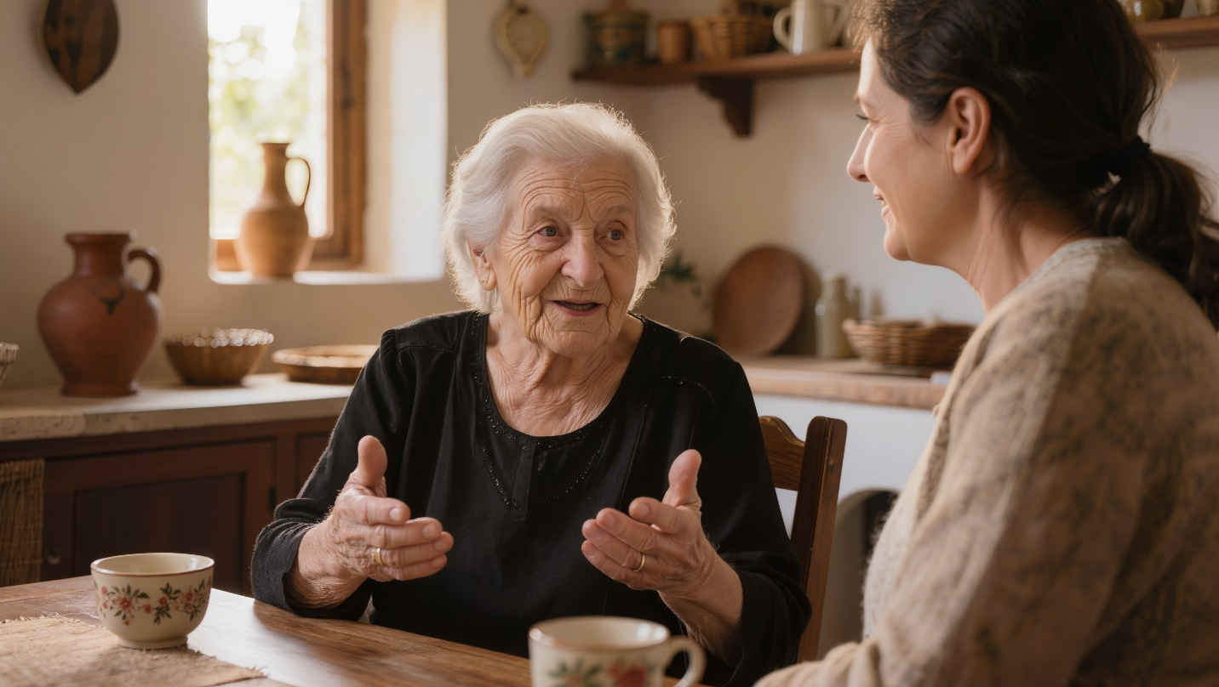

The Power of Oral History: How Time Pencils Gives Voice to the Past
My grandmother sat in her kitchen, hands folded in her lap, and began: “Let me tell you about the day the sky rained soldiers.” I was young enough that the story felt like myth, old enough to understand she was offering me something precious. The details she shared—the sound of bees that became airplane engines, the way Evangelia’s donkey raised its head, the prayer whispered as parachutes filled the sky—these weren’t facts from a textbook. They were memory, still warm, still breathing.
Years later, when I began writing Time Pencils, I understood what my grandmother had been doing. She was performing an ancient human act: passing forward what must not be forgotten. Oral history isn’t just a method of preserving the past—it’s a way of keeping the dead alive, of giving voice to those who never wrote their stories down, of ensuring that what happened to ordinary people in extraordinary times doesn’t vanish into silence.

Key Takeaways
- Oral history captures emotional truth and lived experience that official records often miss
- Stories passed through families preserve details about daily life, psychological states, and community dynamics invisible in military histories
- The act of listening itself becomes a form of witness and validation for those who survived trauma
- Oral narratives reveal how large historical events affected individual lives, making abstract statistics human
- Multiple tellings of the same events create layered understanding, where contradictions often illuminate truth rather than obscuring it
- In cultures like Crete’s, where oral tradition runs deep, stories carry the authority of lived experience
- Writing fiction from oral history requires balancing fidelity to emotional truth with narrative coherence

What the Documents Miss
Military records tell us that approximately 8,000 German paratroopers descended on Crete in May 1941, and roughly 4,000 survived. These numbers convey scale but not experience. They don’t tell us what it felt like to be Evangelia, drawing water for her plants when the humming began. They don’t capture the moment of recognition—those aren’t umbrellas—or the cold fear that settled in her stomach as she crossed herself and whispered “Panagia mou.”
“Oral history isn’t just a method of preserving the past—it’s a way of keeping the dead alive, of giving voice to those who never wrote their stories down.”
Official histories document troop movements and strategic outcomes. Oral histories document the boy who found German boots and died of septic infection because he wore them despite the blisters. The widow who made candles for the church while her son fought on the mainland. The deacon who hung Hitler’s certificate on his wall as camouflage for the radio hidden in his bedroom. These granular truths create texture that transforms our understanding of occupation from abstract concept to lived reality.

The Kitchen as Archive
Throughout my research, I noticed where stories were told: kitchens. Over tea sweetened with precious honey, between the rhythms of food preparation, during the quiet hours after children slept—this was when memory surfaced. The kitchen was neutral ground, domestic space where guarded elders felt safe enough to speak.
Penelope’s kitchen, where Evangelia sought advice about Mihalis’s illness, became a model for how information actually moved during occupation. Not through formal meetings or official channels, but through the intimate geography of women’s daily rounds. Cousin visiting cousin, neighbor bringing vegetables, friends sharing tea—these moments of connection doubled as intelligence briefings, strategy sessions, mutual support.
The stories shared in these spaces carried a different quality than public testimony. They included admissions of fear, moments of doubt, small betrayals and large forgiveness. One woman told me her grandmother had confessed to being terrified every moment the British airman hid in their basement, that she’d vomited from anxiety but forced herself to smile and bring him food. That detail—the gap between composed exterior and churning interior—never appears in heroic narratives but rings absolutely true to anyone who has lived through sustained fear.

Listening as Witness
When elderly Cretans shared their memories with me, they were doing more than transmitting information. They were asking me to witness what they had witnessed, to carry forward what they had carried. Some wept while speaking. Others grew silent, staring past me at something I couldn’t see. A few asked me to turn off my recording device for certain parts, trusting me to remember without mechanical aid.
This act of listening became sacred responsibility. These were stories some had never told their own children, either from desire to protect them or from inability to speak. Trauma has its own timeline, and for many survivors, the distance of decades was required before words could form around certain experiences.
One man described watching his neighbor executed in the plateia. He was eight years old at the time. He told me this story seventy years later, and his hands still shook. “I never told my children,” he said. “What good would it do? But you—you’re writing it down. Maybe that means something.” The weight of that trust still sits heavy on my chest.

The Contradictions That Illuminate
Oral histories rarely align perfectly. Three people describing the same event will offer three different versions—different details, different emphasis, sometimes different basic facts. Academic historians sometimes view this as weakness, preferring the apparent certainty of written documents.
But I learned to see contradictions as revealing rather than problematic. One person remembered the British airman as tall, another as short. But both remembered his youth, his fear, his gratitude. One family insisted their grandmother hid two resistance fighters, another said three. The number mattered less than the unanimous agreement about her courage and the terrible risk she took.
“These granular truths create texture that transforms our understanding of occupation from abstract concept to lived reality.”
These variations reflect how memory works—not as photograph but as living interpretation, shaped by the teller’s position, personality, and what they needed to remember or forget in order to survive. The emotional truth remained consistent even when factual details diverged. Everyone agreed about the sound of German boots on cobblestones, the smell of fear, the grinding anxiety of occupation.

The Stories Not Told
Silence speaks too. Certain subjects prompted immediate changes—voices dropping, eyes shifting, conversations redirected. I learned to recognize these moments and respect them. Some stories were still too dangerous to tell, not because the Nazis would return but because naming certain collaborators would wound families still living in the village.
Other silences protected the storytellers themselves. One woman would discuss every aspect of occupation except the three months after her son disappeared. Those months were blank space in her narrative, and I didn’t press. Some losses remain too large for words even decades later.
Writing Time Pencils required honoring these silences while creating narrative coherence. I couldn’t leave blank space on the page where memory failed or refused to go. So I filled gaps with imagination grounded in what I’d learned about how people behaved under those conditions. But I remained aware that my imaginings were approximations, echoes of truths I’d never fully grasp.

Translating Silence into Story
The challenge in writing fiction from oral history is transformation without betrayal. How do you take fragments—a gesture remembered, a phrase repeated, an emotion conveyed through tone rather than words—and build coherent narrative that honors the source while serving the story?
When Mihalis jokes about his “high waters” while discussing his urinary difficulties, that gallows humor came directly from how elderly Cretan men discussed health problems—with deflecting humor that acknowledged suffering while refusing to be defined by it. When Evangelia weaves while anxiety churns her stomach, that came from multiple women describing how repetitive work calmed fear during occupation.
I aimed for what I think of as emotional fidelity: getting the feelings right even if specific circumstances were invented. Mihalis might not have existed, but his experience of being forbidden medical care, his wife’s search for alternative remedies, the deacon’s attempt to intervene—these patterns repeated across multiple oral histories. By combining them in one fictional family, I hoped to create representative truth.

The Authority of Experience
In Cretan culture, oral tradition carries deep authority. The elder who says “I was there, I saw it” speaks with weight no written document can match. This created interesting tensions in my research. Sometimes oral accounts contradicted written records. Usually, I trusted the oral version—not because documents lie but because they’re incomplete, filtered through official perspectives that often missed what mattered to people living through events.
When written histories said Cretans “welcomed” Allied soldiers, oral histories said it was more complicated—yes, but also terrified, also calculating risk, also sometimes resentful of danger brought to their doorsteps. Both things were true. The oral accounts added dimension official records lacked.

Voice and Vernacular
One gift of oral history is voice—the specific rhythm and vocabulary of how people actually speak. When my research subjects switched to Cretan dialect for certain stories, or inserted Greek phrases into English narration, they were doing more than translating. They were returning to the linguistic landscape where events occurred, finding words that matched memory.
This influenced how I wrote dialogue in Time Pencils. Characters speak English on the page, but I tried to preserve the cadence and construction of Greek speech—the rhetorical questions, the proverbs, the indirect approaches to difficult subjects. When the Diako asks Mihalis “Do you have your old sakouli?” and Mihalis understands this means “We need to speak privately,” that reflected how crisis communication actually worked—coded, cautious, relying on shared context.

The Weight of Inheritance
Writing Time Pencils from oral histories made me acutely conscious of inheritance. These weren’t my stories to tell, yet they’d been entrusted to me for telling. I carried responsibility to the sources—to represent their experiences honestly—but also to readers who needed narrative coherence and emotional engagement.
Sometimes these obligations conflicted. The truth might be fragmented, contradictory, or dramatically unsatisfying. Fiction requires shape that life rarely provides. I had to make choices about which details to emphasize, which characters to develop, where to compress time or expand moments for dramatic effect.
Each choice felt weighted with the question: Does this honor the source? If the people who told me these stories read what I’ve written, will they recognize their truth even if they don’t recognize specific events? This became my standard for success—not historical accuracy in every detail but fidelity to the texture of lived experience.

Final Thought
My grandmother has been dead many years now, but her voice remains. When I wrote the scene of paratroopers descending over Kastelli, I heard her rhythm, her pause before the moment of recognition, her whispered prayer. Oral history gave me that gift—not just information but presence, the sensation of standing beside her as the sky rained soldiers. In writing Time Pencils, I attempted to pass that gift forward, to create for readers the same sense of intimate witness that oral storytelling creates for listeners. The past isn’t past when someone who lived it speaks directly to you across decades. It becomes present tense, urgent, alive. Stories told kitchen to kitchen, grandmother to grandchild, survivor to witness—these are how we keep the dead among us, how we honor what they endured, how we ensure that suffering and courage both find voice. The written word fixes these stories in a different way than oral tradition does, makes them accessible to those who never sat in those kitchens. But the foundation remains the same: someone who was there, who saw it, who carried it for decades, finally finding the moment and the listener worthy of unburdening. That transaction—the telling and the receiving—is holy work. Everything else is just writing it down.

Discussion Questions
- Why might oral histories contradict official historical records, and when should we privilege one source over the other?
- How does the author’s use of oral history in fiction differ from academic oral history projects, and what are the ethical implications of transforming real testimony into fictional narrative?
- What gets lost and what gets gained when oral histories are translated into written form?
- Why do you think certain stories can only be told in specific spaces (like kitchens) or to specific listeners?
- How does understanding that Time Pencils is built from oral histories change your reading experience compared to purely invented historical fiction?

FAQ
Q: How much of Time Pencils comes directly from oral histories versus the author’s imagination?
A: The broad patterns, emotional textures, and many specific details come from oral histories—how people spoke, what they feared, how they resisted. Specific characters and plot events are invented, but they’re built on foundations of documented experience. Think of it as representative fiction rather than documentary.
Q: Did the author face resistance from people who didn’t want their stories told?
A: Yes, some people declined to share, and others shared with restrictions. The author honored these boundaries by using composite characters and avoiding identifiable details when requested. Some stories were told off-record and influenced understanding without being directly transcribed.
Q: How reliable is memory, especially about traumatic events from decades ago?
A: Memory isn’t perfect reproduction—it’s reconstruction shaped by time, emotion, and subsequent experience. But emotional memory often proves remarkably consistent. People might disagree about whether an event happened on Tuesday or Wednesday, but they agree about how it felt, what it meant, and what it cost.
Q: What’s the difference between oral history and folklore?
A: Oral history typically refers to first-person testimony from people who experienced events, while folklore includes traditional stories passed down through multiple generations. Time Pencils draws primarily on oral history (direct testimony) but is also influenced by Cretan folklore traditions that shape how stories are told.
Q: Can readers access the original oral histories that informed Time Pencils?
A: Some oral histories from Cretan WWII survivors have been collected by museums, academic projects, and cultural organizations. However, many of the private interviews conducted for this project remain unpublished to protect privacy and honor agreements with sources.

Sources
- Evangelia - https://oxidayfoundation.org/annual-celebration/the-oxi-day-battle-of-crete-award/
- Oral history - https://www.loc.gov/collections/oral-history/
- Crete - https://en.wikipedia.org/wiki/Battle_of_Crete
- oral tradition - https://www.cretan-history.gr/en/oral-tradition/
- Cretan dialect - https://en.wikipedia.org/wiki/Cretan_dialect
- paratroopers - https://pappaspost.com/may-20-1941-battle-of-crete/
- occupation - https://www.ww2wrecks.com/portfolio/nazi-atrocities-in-crete-murdering-civilians-women-and-children/
- Cretan culture - https://en.wikipedia.org/wiki/Cretan_resistance
- trauma - https://www.ncbi.nlm.nih.gov/books/NBK207191/
- memory - https://www.apa.org/monitor/2012/07-08/ce-corner
- Allied soldiers - https://www.iwm.org.uk/history/the-battle-of-crete
- emotional fidelity - https://www.jstor.org/stable/10.5406/j.ctt1n7zkgj
- inheritance - https://www.tandfonline.com/doi/full/10.1080/1369118X.2019.1672769

