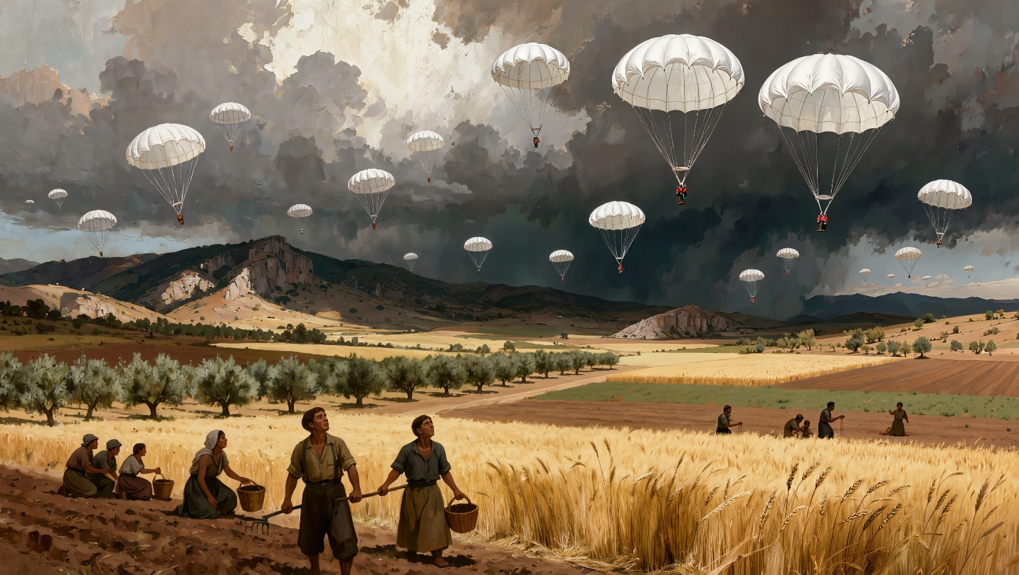

Exploring the Real History Behind Time Pencils: The Cretan Resistance in WWII
The Meltemi winds that sweep across Crete carry more than the scent of thyme and salt air. They carry memory. Throughout my years exploring the stories that became Time Pencils, I learned that history in Crete isn’t something confined to textbooks—it lives in the cracked hands of a potter shaping clay from the same earth his grandfather worked, in the careful way an elderly woman crosses herself when German boots are mentioned, in the silence that falls when certain village squares are named.
Writing about the Cretan resistance during World War II meant understanding that resistance wasn’t always dramatic. Sometimes it was an old man refusing to abandon his daily walk to the pottery studio despite Nazi restrictions. Sometimes it was a woman weaving blankets in her upstairs room while hiding a wireless operator in her basement. The courage I encountered in oral histories wasn’t the manufactured heroism of cinema—it was the quiet, grinding determination of people who simply would not bend.

Key Takeaways
- The Battle of Crete in May 1941 changed the course of WWII, delaying Hitler’s invasion of the Soviet Union and reducing troops available for Middle Eastern campaigns
- Cretan civilians—men, women, and children—fought Nazi paratroopers with farming tools, antiquated rifles, and bare hands during the initial invasion
- The resistance operated through intricate networks connecting monasteries, mountain caves, pottery studios, and private homes across the island
- Nazi reprisals were swift and brutal, including mass executions, village burnings, and the slaughter of entire male populations in certain towns
- Despite four years of occupation and savage reprisals, the Cretan resistance never ceased operations until German surrender in 1945
- Ordinary acts—sharing bread, hiding a radio, walking a goat trail at night—became revolutionary choices that risked immediate execution
- The Cretan concept of philotimo (love of honor) and centuries of resisting foreign occupation created a cultural foundation for sustained resistance
- Women played crucial roles as information carriers, providers of safe houses, and active participants in sabotage operations

The Day the Sky Rained Soldiers
In May 1941, the people of Thrapsano were working their fields as they had for generations. Evangelia walked her donkey in circles around the well, drawing water for young plants pushing through the soil. Boys weeded between rows, waiting for the signal that would send them home for breakfast. The morning was ordinary until it wasn’t.
“The courage I encountered in oral histories wasn’t the manufactured heroism of cinema—it was the quiet, grinding determination of people who simply would not bend.”
The humming began as a distant vibration, then grew into a thrumming that reminded Evangelia of the bees in wooden boxes at the field’s edge. What appeared over Kastelli looked like umbrellas falling from planes high above the mountains. The boys began shouting. Evangelia crossed herself and whispered, “Panagia mou”—Holy Mother of God.
These were not umbrellas but parachutes, and beneath their canopies dangled young German soldiers of the Fallschirmjäger, Hitler’s elite paratroopers. They had been told Cretans would welcome them with open arms. Instead, they met pitchforks, knives, and antiquated firearms. Village women rushed into orchards to attack descending soldiers. Some paratroopers died before touching Cretan soil, caught in trees or swept into the sea. Of approximately eight thousand paratroopers dropped across Crete that day, only around four thousand survived to assist in occupying the island.

Why Crete Mattered
Understanding the strategic importance of Crete requires seeing the island as Hitler saw it: a stepping stone. Located at the crossroads of three continents, Crete commanded shipping lanes critical to Allied operations in North Africa and the Mediterranean. Its airfields could support Luftwaffe operations across the region. More importantly, Crete represented a test of a new kind of warfare—large-scale airborne invasion without ground troop support.
When the Battle of Crete resulted in such devastating German losses despite ultimate Axis victory, Hitler drew conclusions that altered his military strategy. The delay caused by fierce Cretan resistance meant Operation Barbarossa, the invasion of the Soviet Union, began weeks later than planned. Those weeks mattered. German troops reached the outskirts of Moscow just as winter set in, contributing to one of the most significant turning points of the war.
The Cretan resistance also tied down German divisions that might otherwise have reinforced North African campaigns. Every soldier stationed in Crete to control the “obstinate” population was a soldier unavailable elsewhere. The island became a constant drain on German resources and morale.

Networks of Silence and Signal
In chronicling the family I came to know through Time Pencils, I learned that resistance in Crete operated through layers most outsiders never glimpsed. A deacon might hang a certificate from Hitler on his wall—not from sympathy, but because the certificate kept German soldiers from searching his home where a radio was hidden. An elderly potter might time his daily walks to pass information to a cousin who tended bees. Women carrying baskets of vegetables moved intelligence between villages while German patrols assumed they saw only frightened peasants.
The resistance wasn’t centralized in the way military operations typically function. It was organic, rooted in family connections that stretched across the island like the roots of ancient olive trees. When a wireless operator needed to move between mountain caves, shepherds provided cover. When Allied soldiers needed evacuation routes, monastery networks guided them over mountain passes German troops feared to traverse. When food grew scarce, families shared what little they had with hidden airmen and fighters in the hills.
“A deacon might hang a certificate from Hitler on his wall—not from sympathy, but because the certificate kept German soldiers from searching his home where a radio was hidden.”
The Special Operations Executive worked alongside Greek military and Cretan irregulars, but the foundation of every operation was local knowledge. The Doundoulakis brothers—George and Helias, American-born citizens who had returned to Crete as children—served as translators and intelligence gatherers precisely because they understood the cultural landscape. They knew which families could be trusted absolutely, which mountain paths avoided German patrols, which tunnels connected to Heraklion’s port.

The Cost of Defiance
Nazi reprisals were designed to terrorize. For every act of sabotage, innocent villagers paid with their lives. In some villages, German officers forced the male population into churches, then burned the buildings to the ground with everyone inside. In others, men were lined up in village squares and every other man was shot in the temple—forcing survivors to witness again and again, leaving psychological wounds that never healed.
The execution of fifty resistance members following the sabotage at Heraklion airfield sent a clear message: cooperation with Allied forces meant death. Yet the message failed. The executions hardened resolve rather than breaking it. When writing about Mihalis, the elderly potter forbidden from leaving Thrapsano to see his doctor, I struggled with how to convey the grinding humiliation of occupation—the daily indignities that accumulated like stones in a sack until simple survival became an act of resistance.
Cretans understood the mathematics. They knew each act of defiance would be answered with blood. They acted anyway. This wasn’t recklessness but calculation of a different sort. They were measuring present suffering against future freedom, immediate danger against the preservation of philotimo—that uniquely Greek concept encompassing honor, dignity, and the obligation to do right regardless of cost.

Monasteries as Fortresses
The Monastery of Saint George Epanosifis became a nerve center for resistance operations, its seventeenth-century Venetian walls concealing a fifty-foot antenna that facilitated communication with Allied forces. The monk Anthimos Vasilakis worked directly with the Greek Army and secret services, coordinating the movement of personnel through the monastery and over mountains to evacuation points.
The Germans knew transmissions were occurring. Their triangulation equipment detected signals. But locating the source meant venturing into terrain where ambushes were likely and every shepherd might be a fighter. The SS and Gestapo grew increasingly frustrated as signals continued despite their best efforts to track them down.
Wireless operators moved constantly, never staying in one cave or sheepfold more than a few days. They relied on runners—young men who could traverse twenty kilometers of mountain trails in conditions that would exhaust trained soldiers. These runners carried messages, supplies, and occasionally components for radio equipment, moving in darkness along paths known only to those who had herded sheep there for generations.

The Rhythm of Resistance
Throughout my research, I was struck by how resistance folded itself into the rhythms of daily life. A woman might weave blankets upstairs while a British airman slept in her basement. A potter might shape clay while mentally reviewing the route a runner would take that night. Children gathered wood for cooking fires and noted which German patrols passed at which times.
The mundane became strategic. Knowing when guards changed shifts, which officers preferred certain routes, who among the occupiers showed moments of human decency—all this information accumulated and circulated through networks invisible to outsiders. The Germans controlled the roads and the daylight hours, but they never controlled the darkness or the mountains. They never truly controlled Crete.
“The Germans controlled the roads and the daylight hours, but they never controlled the darkness or the mountains. They never truly controlled Crete.”
Food became both weapon and offering. When German forces requisitioned crops intended for memorial services, for wedding celebrations, for christenings, Cretans swallowed their rage and waited. When they fed a hidden airman their last portion of cheese, they made a choice about which future they were building.

Women in the Shadows
The role of Cretan women in the resistance deserves its own examination, but even in brief consideration, their contribution emerges as fundamental. While men often operated in the mountains or handled weapons, women moved through villages with an apparent invisibility that made them perfect intelligence carriers. A woman with a basket of vegetables could pass German checkpoints with less scrutiny than a man.
Women hid radios, sheltered fugitives, carried messages, and maintained the networks that fed resistance operations. They also bore the particular burden of watching—watching as sons and husbands disappeared into mountains or graves, watching as villages burned, watching as occupiers strutted through squares where children once played. Their testimony, preserved in oral histories, carries a weight that transcends individual grief.

The Long Endurance
Four years. The German occupation of Crete lasted four full years, from May 1941 until the surrender in May 1945. Four years of curfews, executions, hunger, and fear. Four years of maintaining networks, hiding fugitives, sabotaging operations. Four years of choosing, again and again, to resist despite knowing the cost.
In exploring this history through Time Pencils, I found myself returning repeatedly to questions about what sustains such endurance. The answer, I believe, lies partly in Crete’s long history of occupation and resistance. Venetians, Turks, and now Germans—the island had weathered foreign control before and always emerged distinctly Cretan. The cultural memory of resistance ran deep.
But endurance also came from something more immediate: the interconnection of family and community. When everyone is implicated, when children and grandparents share the risk, surrender becomes impossible. You cannot betray your cousin without betraying yourself. You cannot abandon the network without abandoning everyone you love.

Lessons Written in Clay and Stone
The pottery of Thrapsano, shaped from the clay soil that gives Crete its name, served purposes beyond the utilitarian. Large pitharia stored olive oil and grain, yes, but they also hid documents and small arms. The same hands that shaped vessels for bread dough shaped the tools of resistance. This blending of the ordinary and the extraordinary characterized the entire Cretan experience of occupation.
Walking through Thrapsano today, you can still see the squares where the stories in Time Pencils took place, the churches where communities prayed for deliverance, the fields where paratroopers landed. The landscape holds its history close. But the deeper truth lives in the stories still told, in the way an old woman’s eyes change when certain names are spoken, in the careful respect shown to those who survived.
The Cretan resistance mattered not only for its military impact—though that was significant—but for what it demonstrated about human capacity for sustained defiance. When writing Time Pencils, I tried to honor both the dramatic moments and the grinding daily choice to continue. The parachutes falling from the sky made for gripping narrative, but the real story was in what came after: the years of walking donkeys to fields, weaving blankets, tending chickens, and never, ever bending.

Final Thought
History in Crete isn’t past tense. It’s present in the clay soil potters still work, in the mountain trails shepherds still walk, in the winds that still carry the scent of thyme across the Pediados plain. The resistance of 1941-1945 was built on centuries of memory and created decades of legacy. Those who fought weren’t thinking of how their story would be told—they were thinking of tomorrow’s bread, tonight’s radio transmission, next week’s evacuation route. But in choosing to act despite the cost, they wrote a chapter of history that still instructs us in the meaning of courage, the power of community, and the stubborn refusal of the human spirit to accept subjugation. The story of Cretan resistance isn’t about the glory of war; it’s about the quiet determination of people who would not surrender their dignity, their honor, or their freedom, no matter how long the occupation lasted or how high the cost climbed.

Discussion Questions
- How did the cultural concept of philotimo (love of honor) contribute to the Cretan people’s sustained resistance despite brutal reprisals? Can you identify modern parallels where cultural values have shaped collective responses to occupation or oppression?
- The article describes how ordinary activities—weaving, pottery-making, tending animals—became integrated with resistance operations. What does this tell us about the nature of civilian resistance movements, and how might this understanding change our perception of wartime heroism?
- Nazi reprisals were designed to break resistance through terror, yet they often hardened Cretan resolve instead. Why do you think this strategy failed in Crete when similar tactics have succeeded in breaking resistance movements elsewhere?
- Women played crucial but often invisible roles in the Cretan resistance, using their perceived “harmlessness” as strategic advantage. How does understanding these contributions change our broader understanding of women’s roles in resistance movements throughout history?
- The article suggests that Crete’s long history of resisting foreign occupation (Venetians, Turks, etc.) created a cultural foundation for WWII resistance. How do you think historical memory shapes a population’s response to contemporary crises? What responsibilities do we have to preserve and learn from such memories?

FAQ
Q: How historically accurate is Time Pencils in its portrayal of the Cretan resistance?
A: Time Pencils is a novel inspired by true stories, not a documentary account. The characters and specific events are fictionalized, but they’re built on a foundation of extensive oral history research, historical records, and family narratives. The broader historical events—the paratroop invasion, the Battle of Crete, the network of resistance operations, the role of monasteries and wireless operators, and the nature of Nazi reprisals—are all historically documented. Think of it as emotional truth served through fictional characters rather than a strict historical chronicle.
Q: What happened to Cretan civilians who were caught helping Allied soldiers?
A: The consequences were typically swift and brutal. Individuals caught harboring Allied personnel faced immediate execution, often in public as a deterrent. In some cases, entire families were killed, and occasionally whole villages faced reprisals including mass executions and burning of homes. Despite these horrific consequences, many Cretans continued to shelter and assist Allied soldiers throughout the occupation, demonstrating extraordinary courage and commitment to resistance.
Q: How did the Cretan resistance communicate across the island when Germans controlled the roads?
A: The resistance used multiple communication methods: runners who traveled mountain paths at night, wireless radio operators who moved constantly between hidden locations, monastery networks with concealed antennas, and trusted messengers who appeared to be ordinary civilians going about daily business. The resistance also used coded messages embedded in seemingly innocent activities—certain songs played on the radio, specific patterns of movement, and pre-arranged signals. The network relied heavily on family connections and centuries-old knowledge of the island’s terrain.
Q: What was the strategic importance of Crete that made Germany invest so heavily in its capture and occupation?
A: Crete’s location at the crossroads of three continents made it strategically vital for controlling Mediterranean shipping lanes and supporting operations in North Africa and the Middle East. Its airfields could host Luftwaffe aircraft for operations across the region. Additionally, Hitler saw Crete as a test case for large-scale airborne invasion tactics. After the costly victory, the heavy German losses influenced Hitler’s military decisions, including the delayed invasion of the Soviet Union—a delay that had significant consequences for the broader war.
Q: Are there still visible remnants of the WWII resistance and occupation in Crete today?
A: Yes, evidence remains throughout the island. Village squares where executions occurred, churches that served as sites of massacre, mountain caves used as hideouts, and memorial sites marking specific atrocities are preserved. Many villages have monuments honoring resistance fighters and civilians killed during the occupation. Additionally, museums in major cities house artifacts, documents, and exhibits dedicated to this period. Perhaps most significantly, the oral history lives on through survivors and their descendants, keeping the memory alive in family narratives passed down through generations.

Sources
- Meltemi winds - https://www.sailogy.com/en/blog/meltemi-wind-cyclades/
- Crete - https://en.wikipedia.org/wiki/History_of_Crete
- Cretan resistance - https://www.antonybeevor.com/book/crete-the-battle-and-the-resistance/
- World War II - https://guides.loc.gov/ww2/library-of-congress-resources
- Fallschirmjäger - https://battlefrontmalta.com/the-origins-of-the-fallschirmjager/
- Battle of Crete - https://en.wikipedia.org/wiki/Battle_of_Crete
- Hitler - https://www.nationalarchives.gov.uk/education/resources/adolf-hitler/
- Soviet Union - https://libguides.fau.edu/primary-sources-ww2/soviet-union
- Luftwaffe - https://libguides.fau.edu/germany-world-war-two/germany-luftwaffe-experience
- Operation Barbarossa - https://www.iwm.org.uk/history/operation-barbarossa-and-germanys-failure-in-the-soviet-union
- North African campaigns - https://en.wikipedia.org/wiki/North_African_campaign
- Special Operations Executive - https://en.wikipedia.org/wiki/Special_Operations_Executive
- Doundoulakis brothers - https://en.wikipedia.org/wiki/Cretan_resistance
- philotimo - https://www.greekboston.com/culture/ancient-history/philotimo/
- Monastery of Saint George Epanosifis - https://greekcitytimes.com/2023/07/04/holy-monastery-agios-georgios-epafonisis-2-2/
- SS - https://encyclopedia.ushmm.org/content/en/article/ss
- Gestapo - https://encyclopedia.ushmm.org/content/en/article/gestapo

